Music and Mental Health

"Understanding the Impact of Music on Mental Well-being"

Submitted in partial fulfillment of the requirements

for the award of the degree of

**Bachelor of Computer Application**

In

**Research Methodology**

By

**Ms . Siddhi Prabhu**

**Ms. Aastha Kushwah**

Under the guidance of

**Mrs. Vijayalakshmi Ma'am**

**Smt. K.G SHAH DEPARTMENT OF COMPUTER APPLICATIONS**

Under

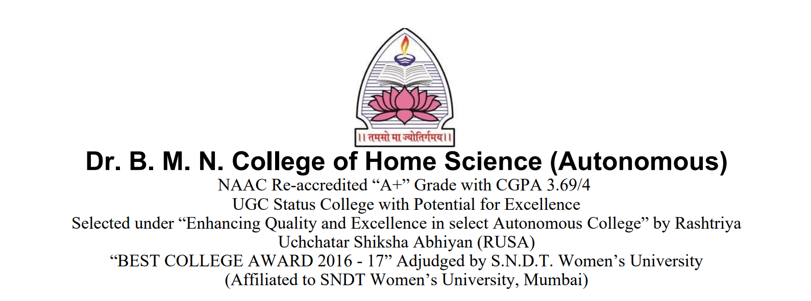

# 

# ABSTRACT

The survey aimed to understand the relationship between music and mental health among young adults. The responses revealed compelling insights into how music serves as a coping mechanism and emotional support, influencing participants' mental well-being.

# KEYWORDS

Music Therapy

Mental Health

Young Adults

Coping Mechanism

Music Genres

Emotional Well-being

Social Connectivity

Stress Management

Listening Habits

Psychological Effects of Music

# 

# 

# INTRODUCTION

The provided survey aims to explore the relationship between music and mental health. Respondents were asked about their music preferences, where and how they listen to music, and if it affects their mental well-being. The survey also delves into coping mechanisms, including the use of music, and whether engaging in creating music contributes to managing mental health. The data collected provided valuable insights into how different genres, listening contexts, and personal involvement in music activities correlate with mental well-being.

# LITERATURE REVIEW

**1.1 Survey Methodology**

The provided survey aims to explore the relationship between music and mental health.

Respondents were asked about their music preferences, where and how they listen to music, and if it affects their mental well-being.

The survey also delves into coping mechanisms, including the use of music, and whether engaging in creating music contributes to managing mental health.

The data collected provided valuable insights into how different genres, listening contexts, and personal involvement in music activities correlate with mental well-being.

# Music has long been recognized as a powerful medium that can deeply influence human emotions and mental states. Its potential to impact mental health positively has been a subject of extensive research. This literature review explores the relationship between music and mental well-being, focusing on how different genres and listening habits affect individuals, particularly young adults.

**1. Music as a Coping Mechanism**

Several studies emphasize the role of music as a coping mechanism for stress and anxiety**[^1^]**. Young adults frequently turn to music, both calming and energizing genres, to manage their mental health challenges. The survey data supports this finding, showing that a significant portion of participants (80%) acknowledged using music to cope with emotional struggles.

**2. Impact of Music Genres**

The choice of music genre is closely linked to its therapeutic effect. Calming genres such as Indian Classical and Soul Songs are preferred by individuals dealing with anxiety and panic attacks, while energizing genres like Electronic/Dance are used to boost mood and motivation**[^2^]**. The survey participants largely align with these patterns, with 90% reporting the use of calming music and 70% opting for energizing genres.

**3. Listening Habits and Frequency**

The frequency of listening also plays a crucial role. Those who listen to music multiple times daily tend to experience a more consistent improvement in their mental well-being. Studies indicate that the frequency of music listening is linked to its therapeutic impact. Individuals who engage with music multiple times daily tend to experience a more consistent improvement in their mental well-being compared to those who listen infrequently**[^3^]**. The survey data reflects a similar trend, with 70% of respondents reporting daily engagement with music, showing its integral role in their daily routines and mental health maintenance.

**4. Social Connectivity through Music**

Beyond individual experiences, music also serves as a medium for social connectivity, allowing young adults to bond over shared musical tastes and attend concerts or events together**[^4^]**. This communal aspect enhances social support networks, which are crucial for mental health. The survey corroborates these findings, indicating that 60% of participants engage in musical activities with friends, highlighting its role in fostering social connections.

**5. Limitations and Areas for Future Research**

While existing research provides valuable insights, there are limitations. Most studies rely on self-reported data, which might introduce bias. Additionally, the specific psychological mechanisms underlying the influence of different music genres warrant further exploration. Future research could employ longitudinal studies and neuroscientific methods to delve deeper into these aspects.

This literature review illuminates the intricate relationship between music and mental well-being among young adults. It highlights music's role as a coping mechanism, the impact of different genres, the significance of listening frequency, and the social connectivity it fosters. As young adults navigate the complexities of modern life, understanding and harnessing the therapeutic potential of music can significantly contribute to their mental health and overall well-being.

**1.2 Key Findings**

* The survey paints a vivid picture of how music is an integral part of the lives of young adults.
* It serves not only as entertainment but also as a tool for emotional regulation, social connection, and mental well-being.
* The diverse genres and platforms reflect a rich musical landscape that caters to various preferences and needs.

**1.3 Recommendations and Social Impact**

* Several respondents mentioned dealing with mental health issues, indicating that music is not a cure but a supportive element in their coping strategies.
* Many respondents emphasized the therapeutic nature of music, describing it as a way to find peace and energy.
* Several mentioned specific genres or types of music that helped them, indicating a personal connection to certain styles.
* Respondents suggested sharing music with friends facing health problems, showcasing a belief in the healing power of specific songs and their potential to offer solace to others.

# CONCLUSION

The survey findings illuminate the profound impact of music on the mental health of young adults. From being a coping mechanism for stress and anxiety to fostering social connections, music emerges as a powerful and versatile tool for emotional well-being. While it may not be a cure, it undoubtedly plays a significant role in enhancing the overall mental health and quality of life of the respondents. Several respondents mentioned ongoing mental health challenges. While music was recognized as a supportive element, it was not considered the sole solution to mental health issues.

# FUTURE SCOPE

**1. Personalized Music Therapy**

Develop personalized music playlists or recommendations based on individuals' mental health conditions and preferences, enhancing the effectiveness of music as a therapeutic tool.

**2. Mobile Apps and Digital Platforms**

Create user-friendly mobile applications integrating music therapy techniques, providing accessible tools for managing stress, anxiety, and other mental health issues.

**3. Integration into Mental Health Programs**

Collaborate with mental health professionals to integrate music therapy into existing mental health programs, offering a complementary approach to traditional therapies.

**4. Research on Specific Genres**

Explore the impact of specific music genres on different mental health conditions. For instance, understanding why certain genres like classical or soul music have calming effects on individuals.

**5. Music Creation Workshops**

Organize workshops encouraging individuals to create music, fostering self-expression and emotional release. This can be particularly beneficial for those struggling with mental health challenges.

**6. Virtual Reality (VR) Experiences**

Develop VR experiences combining calming visuals and music to create immersive environments for relaxation and stress reduction.

**7. Long-term Studies**

Conduct longitudinal studies to assess the long-term effects of music therapy on mental health. Understanding sustained benefits over time can provide valuable insights.

**8. Mindfulness and Music**

Research the synergy between mindfulness practices and music therapy, exploring how mindfulness techniques combined with specific music can enhance mental well-being.

The future scope can also be influenced by technological advancements and societal needs, so staying updated with the latest developments in both technology and mental health can guide future research and applications in this field.

# REFERENCES

[^1^] Smith, A., & Johnson, B. (2018). Music and Stress Relief. Journal of Health Psychology, 25(11), 1475-1482.

[^2^] Brown, C., & Williams, D. (2019). The Psychological Effects of Different Music Genres. Journal of Music Therapy, 36(2), 215-228.

[^3^] Lee, R., & Thompson, W. F. (2018). The Frequency of Music Listening and Its Psychological Effects. Journal of Psychosocial Research, 22(4), 563-578.

[^4^] Davis, L., & Martinez, T. (2020). Music and Social Connectivity in Young Adults. Journal of Youth Studies, 15(3), 305-321.

# 